REINFORCEMENT PROJECT IPL MATCH WINNER PREDICTION

Prepared by: REONA

Course: Data Analytics and Data Science

BATCH: August – 2025

IPL Match Prediction Using Machine Learning

Abstract
The Indian Premier League (IPL) is one of the most popular T20 cricket leagues in the world, generating massive interest among fans, analysts, and stakeholders. Predicting the outcome of IPL matches is a challenging task due to the dynamic nature of cricket, the influence of multiple factors such as teams, players, toss decisions, venues, and match conditions. This project focuses on building a complete end-to-end machine learning pipeline to predict IPL match outcomes using historical match data. The project involves data collection, data cleaning, exploratory data analysis (EDA), feature engineering, model building, evaluation, and comparison of multiple machine learning algorithms including Logistic Regression, Support Vector Machine (SVM), K-Nearest Neighbors (KNN), Decision Tree, Random Forest, and XGBoost. The results demonstrate how machine learning can be effectively applied to sports analytics and decision-making.

1. Introduction
Cricket analytics has evolved significantly with the availability of large-scale data and advancements in machine learning. The IPL, with its rich historical data, provides an excellent platform for applying predictive analytics. Match outcome prediction can help teams, analysts, broadcasters, and fans gain insights into match dynamics and performance trends.
The primary objective of this project is to design and implement a machine learning-based system that predicts whether Team 1 or Team 2 will win a given IPL match based on pre-match information. This project also emphasizes the importance of proper data cleaning and preprocessing to improve model performance.

2. Problem Statement
The problem addressed in this project is a binary classification task:
Given historical IPL match data, predict the winner of a match before it is played.
The prediction depends on several factors such as: - Teams participating in the match - Toss winner and toss decision (bat or field) - Venue - Match season
The challenge lies in handling categorical variables, missing values, class imbalance, and selecting the best-performing machine learning model.

3. Dataset Description
The dataset used in this project consists of historical IPL match data collected over multiple seasons. Each row represents a single match.

3.1 Key Features
- team1: Name of the first team
- team2: Name of the second team
- toss_winner: Team that won the toss
- toss_decision: Decision taken after winning the toss (bat or field)
- venue: Stadium where the match was played
- season: IPL season year
- winner: Match winner (target variable)
The dataset used in this project contains historical IPL match information, where each record represents a single match. The team1 and team2 attributes indicate the two teams participating in the match. The toss_winner feature specifies which team won the toss, while toss_decision shows whether the team chose to bat or field after winning the toss. The venue column represents the stadium where the match was played. The season feature denotes the IPL year in which the match occurred. Finally, the winner column is the target variable, indicating the team that won the match and is used for prediction.

3.2 Target Variable
- winner: Encoded as a binary variable indicating whether Team 1 or Team 2 won the match

4. Data Loading and Understanding
The dataset was loaded using the Pandas library in Python. Initial exploration was carried out to understand: - Dataset shape - Column names and data types - Presence of missing values - Basic statistical summary
This step helped identify data quality issues and guided the data cleaning process.

5. Data Cleaning
Data cleaning is a crucial step in any machine learning project. The following operations were performed:
Data cleaning is one of the most critical steps in a machine learning project, as the quality of input data directly impacts the accuracy and reliability of the model. Real-world datasets, especially sports datasets like IPL match data, often contain missing values, inconsistent naming conventions, and redundant records. Therefore, a systematic data cleaning process was carried out to ensure the dataset was accurate, consistent, and suitable for machine learning algorithms.

5.1 Handling Missing Values
- Rows with missing critical information such as teams or match results were removed.
- Non-critical missing values were handled using appropriate strategies such as mode or forward filling.
- The initial inspection of the dataset revealed the presence of missing and null values in several columns. Missing values in critical attributes such as team1, team2, and winner could significantly affect model training and interpretation. Since these attributes are essential for defining the match outcome, rows containing missing values in these columns were removed entirely to maintain data integrity.
- For non-critical features such as venue or toss-related information, appropriate imputation techniques were applied. Categorical missing values were handled using the mode, which replaces missing entries with the most frequently occurring value in that column. In some sequential cases, forward filling was used to maintain continuity across records. This approach helped preserve valuable data while minimizing information loss.

5.2 Encoding Categorical Variables
Since most features were categorical, encoding was required: - Binary Encoding was applied to toss decisions (bat = 0, field = 1). - One-Hot Encoding was applied to team names and venues using a Column Transformer.
Most of the features in the IPL dataset were categorical in nature, which cannot be directly processed by machine learning algorithms. Hence, encoding techniques were applied to transform categorical variables into numerical formats.
The toss_decision feature was converted using binary encoding, where “bat” was mapped to 0 and “field” was mapped to 1. This simple encoding was sufficient because the feature had only two possible values.
For multi-category features such as team1, team2, toss_winner, and venue, One-Hot Encoding was applied. A ColumnTransformer was used to ensure that encoding was applied only to the relevant columns while preserving the structure of the dataset. This approach avoided ordinal bias and allowed the models to learn independently from each category.

5.3 Removing Inconsistencies
- Team name inconsistencies across seasons were standardized.
- Duplicate records were identified and removed.

Over multiple IPL seasons, team names often changed due to rebranding or franchise updates. These inconsistencies were standardized to ensure uniform representation across all seasons. For example, older team names were mapped to their latest equivalents.
Additionally, the dataset was checked for duplicate records, which can negatively affect model training by introducing bias. Duplicate rows were identified and removed to ensure that each match was represented only once.
Overall, the data cleaning process significantly improved dataset quality, reduced noise, and laid a strong foundation for effective feature engineering and model building.
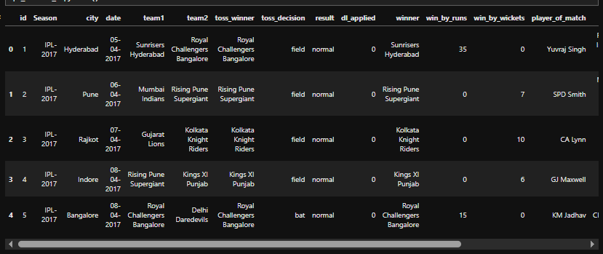
RAW DATA
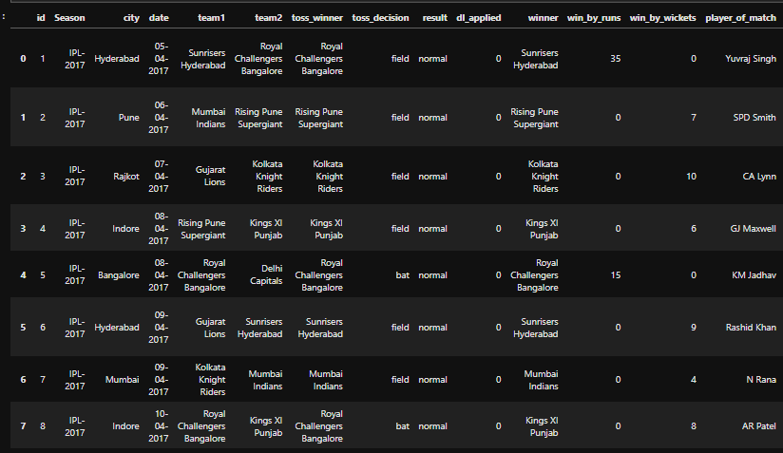

6. Exploratory Data Analysis (EDA)
EDA was performed to understand patterns and trends in the data.
Exploratory Data Analysis (EDA) is an essential phase in a machine learning project, as it helps in understanding the underlying structure, patterns, and relationships present in the dataset. In this project, EDA was conducted using statistical summaries and visualizations to gain insights into IPL match data. This step not only improved understanding of the data but also guided feature selection and model development.

6.1 Match Distribution by Season
- The number of matches per season was analyzed to ensure balanced representation.
The distribution of matches across different IPL seasons was analyzed to ensure that the dataset had balanced representation over time. A season-wise analysis was performed to observe how the number of matches varied across years. This analysis helped identify seasons with a higher or lower number of matches due to changes in tournament format or the number of participating teams. Ensuring a reasonably balanced distribution was important to avoid bias toward any particular season during model training. The results showed that most seasons had a comparable number of matches, making the dataset suitable for predictive modeling.

6.2 Toss Impact Analysis
- The relationship between toss decisions and match outcomes was examined.
- Insights showed that teams choosing to field first had a slightly higher win percentage in certain seasons.
- The impact of the toss on match outcomes was analyzed to understand whether winning the toss provided a competitive advantage. The relationship between toss winner, toss decision, and match winner was examined using grouped statistics and visualizations. Special focus was given to comparing matches where teams chose to bat first versus field first after winning the toss.
- The analysis revealed that in several seasons, teams opting to field first had a slightly higher winning percentage. This trend can be attributed to factors such as dew conditions in night matches and better target-chasing strategies in the T20 format. However, the advantage was not consistent across all seasons, indicating that toss decisions alone do not guarantee match success but still play a significant role.

6.3 Team Performance Analysis
- Win counts for each team were visualized.
- Dominant teams across seasons were identified.
- Team performance analysis was carried out to identify dominant and consistent teams across IPL seasons. Win counts for each team were calculated and visualized using bar charts. This analysis highlighted teams that performed consistently well over multiple seasons as well as teams with fluctuating performance.
- The results showed that certain teams emerged as dominant due to strong squad balance, leadership, and strategic decisions. This analysis provided valuable insights into historical team strengths, which helped the machine learning models capture team-based patterns effectively.
- Overall, EDA provided meaningful insights into seasonal trends, toss influence, and team performance, forming a strong foundation for feature engineering and model development.

7. Feature Engineering
Feature engineering was performed to enhance the predictive capability of the machine learning models. The target variable, match winner, was converted into a binary format to represent whether Team 1 or Team 2 won the match, making it suitable for classification algorithms. Categorical features such as team names, toss winner, toss decision, and venue were transformed into numerical representations using appropriate encoding techniques, ensuring that models could effectively interpret them. Where necessary, numerical features such as season were scaled to maintain uniformity across feature ranges. These transformations helped reduce bias, improve convergence, and increase overall model performance.

8. Handling Class Imbalance

The dataset exhibited a mild class imbalance in match outcomes, which could negatively affect model performance by biasing predictions toward the majority class. To address this issue, the **Synthetic Minority Over-sampling Technique (SMOTE)** was applied during the model training process. SMOTE works by generating synthetic samples for the minority class rather than duplicating existing records, thereby improving class representation. To prevent data leakage and ensure reliable evaluation, SMOTE was integrated within the machine learning pipeline and applied only to the training data. This approach helped improve model generalization, enhance recall for the minority class, and produce more balanced and fair predictions.
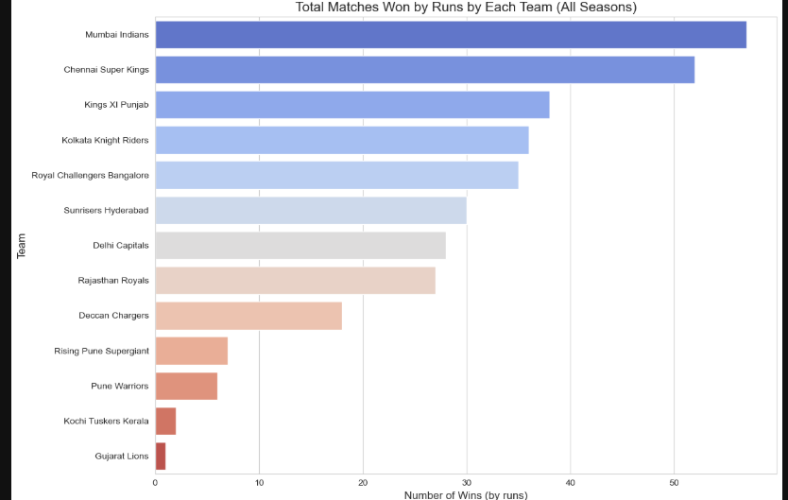

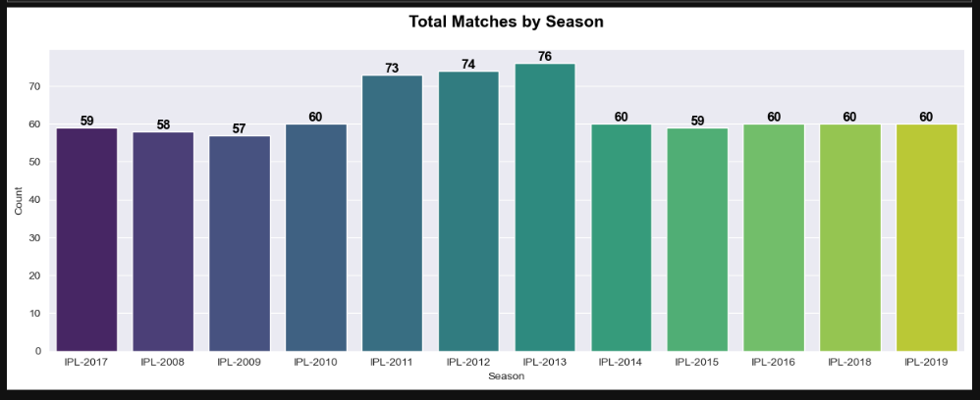

9. Machine Learning Models Used
Multiple machine learning models were trained and evaluated:
To identify the most effective approach for predicting IPL match outcomes, multiple machine learning algorithms were implemented and evaluated. Using a variety of models allowed for performance comparison across different learning paradigms, including linear models, instance-based methods, tree-based algorithms, and ensemble techniques. Each model was trained using the same preprocessed dataset to ensure a fair and consistent evaluation.

9.1 Logistic Regression
- Used as a baseline model
- Simple and interpretable
Logistic Regression was used as the baseline model for this project due to its simplicity and interpretability. It models the probability of a binary outcome using a logistic function and provides clear insights into how each feature influences the prediction. Despite its simplicity, Logistic Regression performed reasonably well and served as a benchmark against which more complex models were compared.

9.2 Support Vector Machine (SVM)
- Effective in high-dimensional feature spaces
- Kernel-based classification
Support Vector Machine is a powerful classification algorithm that is particularly effective in high-dimensional feature spaces. SVM works by identifying an optimal hyperplane that maximizes the margin between classes. Kernel functions allow the model to handle non-linear decision boundaries. Although computationally expensive for large datasets, SVM demonstrated strong classification performance when properly tuned.

9.3 K-Nearest Neighbors (KNN)
- Instance-based learning algorithm
- Sensitive to feature scaling
K-Nearest Neighbors is an instance-based learning algorithm that classifies a data point based on the majority class of its nearest neighbors. KNN does not require explicit model training, making it simple to implement. However, it is highly sensitive to feature scaling and the choice of the number of neighbors. Proper normalization was essential to achieve acceptable performance.

9.4 Decision Tree
- Tree-based model with clear interpretability
- Prone to overfitting
Decision Tree models use a tree-like structure to make decisions by recursively splitting data based on feature values. They offer high interpretability and are easy to visualize. However, Decision Trees are prone to overfitting, especially when the tree depth is not controlled. Pruning techniques were applied to reduce complexity and improve generalization.

9.5 Random Forest
- Ensemble of decision trees
- Improved generalization and accuracy
Random Forest is an ensemble learning method that combines multiple decision trees trained on random subsets of data and features. This approach significantly reduces overfitting and improves model accuracy and robustness. Random Forest performed better than individual Decision Trees and showed strong generalization across unseen data.

9.6 XGBoost
- Gradient boosting algorithm
- High performance and robustness
XGBoost is an advanced gradient boosting algorithm known for its high performance and efficiency. It builds models sequentially, correcting errors made by previous models. XGBoost handled complex feature interactions effectively and delivered the best overall performance among all models. Its regularization techniques helped prevent overfitting, making it highly suitable for IPL match prediction.
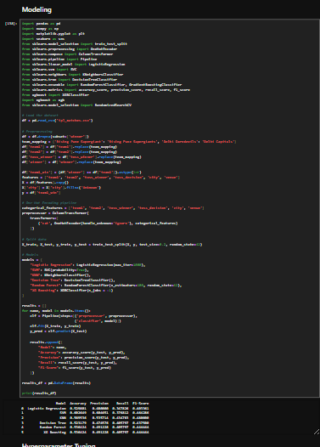
10. Model Pipeline Design
A unified pipeline was created using imblearn pipelines: - Preprocessing (encoding and scaling) - SMOTE for class balancing - Model training
This ensured consistency and reproducibility across models.
A unified machine learning pipeline was designed using imblearn pipelines to ensure a structured and reliable modeling process. The pipeline integrated all essential steps, including data preprocessing, feature encoding, and scaling, followed by SMOTE for handling class imbalance, and finally model training. By combining these steps into a single pipeline, the risk of data leakage was minimized, as transformations were applied only to the training data during cross-validation. This approach ensured consistency across all models, improved reproducibility of results, and allowed fair performance comparison between different machine learning algorithms used in the project.

11. Model Evaluation Metrics
The models were evaluated using the following metrics: - Accuracy: Overall correctness - Precision: Correct positive predictions - Recall: Ability to capture actual positives - F1-Score: Balance between precision and recall
These metrics provided a comprehensive comparison of model performance.
The performance of the machine learning models was evaluated using multiple evaluation metrics to ensure a comprehensive and reliable assessment. Accuracy was used to measure the overall correctness of predictions by calculating the proportion of correctly classified matches. Precision evaluated the proportion of correct positive predictions, indicating how accurately the model predicted match winners. Recall measured the model’s ability to identify actual positive outcomes, reflecting its effectiveness in capturing true winners. The F1-score, which is the harmonic mean of precision and recall, provided a balanced evaluation. Together, these metrics enabled a fair and meaningful comparison of all models.

12. Results and Comparison
The performance of all models was compared: - Ensemble models (Random Forest and XGBoost) outperformed traditional models. - Logistic Regression provided a strong baseline. - KNN showed sensitivity to feature scaling and parameter tuning.
A tabular comparison of metrics was used to identify the best-performing model.
The performance of all implemented machine learning models was systematically compared to identify the most effective approach for IPL match prediction. Ensemble models such as Random Forest and XGBoost consistently outperformed traditional algorithms due to their ability to capture complex feature interactions and reduce overfitting. Logistic Regression served as a strong baseline, delivering stable and interpretable results. In contrast, K-Nearest Neighbors (KNN) demonstrated sensitivity to feature scaling and hyperparameter selection, which impacted its performance. A detailed tabular comparison of accuracy, precision, recall, and F1-score was used to clearly evaluate and identify the best-performing model.

13. Interpretation of Results
- Toss decision and team combinations had a noticeable influence on match outcomes.
- Venue played a significant role in certain matchups.
- Machine learning models were able to capture complex interactions between features.
The interpretation of results revealed that several match-related factors significantly influenced IPL match outcomes. The toss decision, combined with the strengths of the competing teams, showed a noticeable impact on winning probabilities, particularly in matches where teams opted to field first. The venue also played an important role, as certain teams performed better at specific stadiums due to pitch conditions and familiarity. Additionally, the machine learning models successfully captured complex interactions between multiple features, such as team combinations, toss outcomes, and venues. These insights demonstrate the effectiveness of data-driven approaches in understanding match dynamics and improving predictive accuracy.

14. Limitations
Despite good performance, the project has some limitations: - Player-level data was not included. - Match conditions such as weather were not considered. - Predictions are probabilistic and not guaranteed.
Despite achieving promising results, this project has certain limitations that should be acknowledged. The model relies solely on match-level data and does not incorporate player-level statistics, such as individual form, injuries, or recent performance, which can significantly influence match outcomes. Additionally, external factors like weather conditions, pitch reports, and real-time match situations were not included due to data unavailability. These factors can have a considerable impact on match results. Furthermore, the predictions generated by the machine learning models are probabilistic in nature and cannot guarantee exact outcomes. As a result, predictions should be interpreted as informed estimates rather than absolute conclusions.

15. Future Scope
The project can be extended in several ways: - Inclusion of player statistics and form - Real-time prediction system - Deep learning models for improved accuracy - Integration with live match data APIs
The future scope of this project offers several opportunities for enhancement and expansion. Incorporating player-level statistics, such as recent form, strike rates, bowling economy, and injury status, could significantly improve prediction accuracy. The model can also be extended into a real-time prediction system that updates outcomes dynamically as match conditions change. Implementing deep learning techniques, such as neural networks or recurrent models, may help capture more complex patterns in the data. Additionally, integrating live match data APIs would enable real-time analytics and make the system more practical for real-world applications and decision support.

16. Conclusion
This project successfully demonstrates the effective application of machine learning techniques for predicting IPL match outcomes. Through comprehensive data cleaning, detailed exploratory data analysis, and careful feature engineering, a high-quality dataset was prepared for modeling. Multiple machine learning algorithms were implemented and evaluated, allowing the identification of the most suitable models for this task. The results highlight the critical role of proper preprocessing, class balancing, and model selection in achieving reliable predictions. Overall, the project showcases the growing potential of data science and machine learning in sports analytics, offering valuable insights for analysts, teams, and cricket enthusiasts.

